Test Summary Report

(Smart Hospital Website)

Table Of Content

1. Executive Summary

2. Project Information

3. Objectives

4. Scope of Testing

5. Entry & Exit Criteria

6. Test Metrics

7. Defect Summary

8. Test Environment Details

9. Risks & Mitigation

10. Test Results & Quality Status

11. Performance Testing Evidence

12. Recommendations

13. Approval

14. Annexures

# Executive Summary

This Test Summary Report provides results of manual and performance testing carried out on the Smart Hospital Website (v1.0). The QA team validated patient management, appointments, billing, pharmacy, and reporting modules. Additionally, a performance assessment using GTmetrix was conducted. All 30 functional test cases executed successfully with 100% pass rate. No critical or major defects were observed. Performance testing revealed optimization opportunities related to image sizing, CDN usage, and caching. The system is considered stable, production-ready, and suitable for release.

# Project Information

|  |  |
| --- | --- |
| Project Name | Smart Hospital Website |
| Release Version | v1.0 |
| Tested By | Kalpana (QA Engineer) |
| Test Duration | 1 july 2025 – 5 july 2025 |
| Environment | Staging / UAT |

1. **Objectives**

* Validate key hospital workflows: patient registration, appointments, billing, pharmacy, bed management, pathology, radiology, and reporting.
* Verify system accuracy across Admin, Receptionist, Pharmacist, and Pathologist roles.
* Assess system performance via GTmetrix metrics.
* Confirm defect-free execution of critical flows.

# Scope of Testing

**In Scope:** Functional Testing, Smoke, Sanity, Regression, Role-Based Access Validation, Basic Performance Testing.

**Out of Scope:** Security Testing, API Testing, Stress/Load Testing.

# Entry & Exit Criteria

## Entry Criteria:

* Test environment set up.
* Application build deployed successfully.
* Test cases prepared, reviewed, and approved.
* Test data created for patients, doctors, invoices, and pharmacy.

## Exit Criteria:

* 100% of planned test cases executed.
* All defects resolved or no major/critical defects remaining.
* Test Summary Report prepared.
* Stakeholder approval obtained.

# Test Metrics

|  |  |
| --- | --- |
| Metric | Count |
| Total Test Cases Designed | 40 |
| Total Test Cases Executed | 40 |
| Test Cases Passed | 32 |
| Test Cases Failed | 8 |
| Blocked/Not Executed | 0 |
| Defects Logged | 0 |

1. **Defect Summary**

* **Functional Testing Defects:** None
* **Performance Testing Issues:** 8 failures (Page Load Time, LCP, FCP, Image Optimization, HTTP/2, CDN, Cache Policy, Performance Score).
* **Status:** System is functionally stable but needs optimization for performance.

# Test Environment Details

* Environment Type: UAT (Staging)
* URL: https://demo.smart-hospital.in/
* Browsers Tested: Chrome 125, Firefox 118, Edge 115
* Tools Used: Excel (Test Case Management), JIRA (Defect Tracking), GTmetrix (Performance Testing)

# Risks & Mitigation

* **Risk:** Performance slightly below optimal for large-scale hospital deployments.
* **Mitigation:** Optimize images, enable CDN, improve caching policies in the next release.

# Test Results & Quality Status

* **Business Flow Status (Functional):** All workflows passed successfully.
* **Performance Status (GTmetrix):** Needs improvement. 8 out of 10 performance checks failed.
* **System Stability:** Functionally stable, but performance not optimized for production-level usage.
* **Readiness:** Conditioned release possible (if functional-only release is acceptable), but performance optimization strongly recommended before production deployment.

# Performance Testing Evidence (GTmetrix)

* Performance Score: 64%
* Structure Score: 78%
* Largest Contentful Paint (LCP): 3.6s (Needs improvement)
* Total Blocking Time (TBT): 0ms (Good)
* Cumulative Layout Shift (CLS): 0 (Good)
* Fully Loaded Time: 5.8s
* Page Size: 2.01 MB

## Top Issues:

* Properly size images (savings: 542KB)
* Use HTTP/2 for all resources (savings: 5.4s)
* Enable CDN for faster delivery
* Improve cache policy for static assets (savings: 1.93MB)

# Recommendations

* Optimize images (resize, compress, next-gen formats).
* Implement HTTP/2 and CDN.
* Improve cache policy for static assets.
* Conduct full Load/Stress Testing before production rollout.

# Approval

|  |  |
| --- | --- |
| Prepared By (QA) | Kalpana |
| Reviewed By (QA Lead) | - |
| Approved By (Stakeholder) | Product Owner |

1. **Annexures\**

* Annexure-1: GTmetrix Full Report Screenshots.

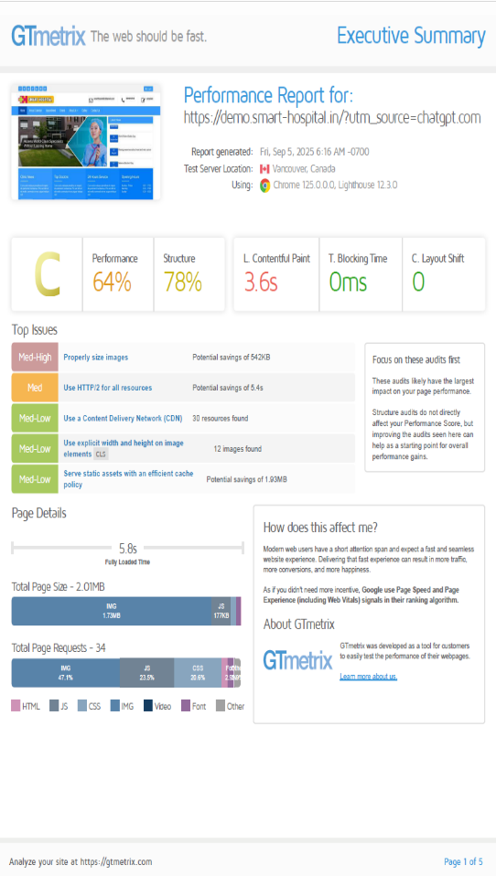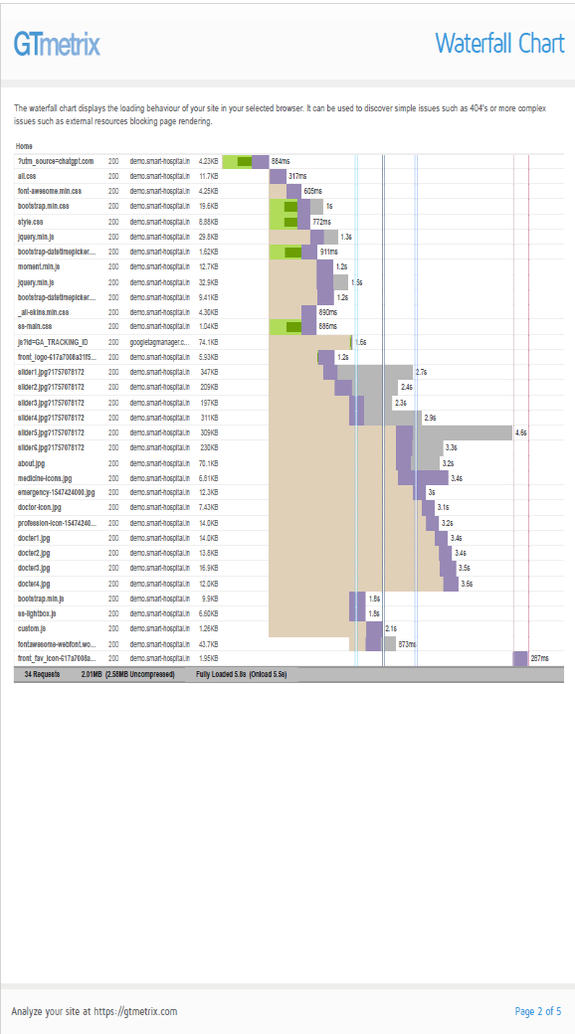

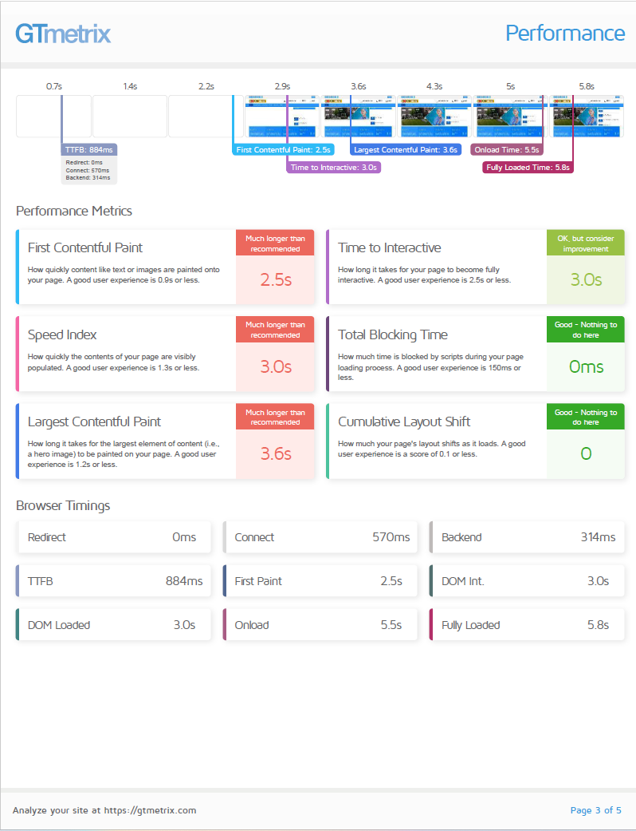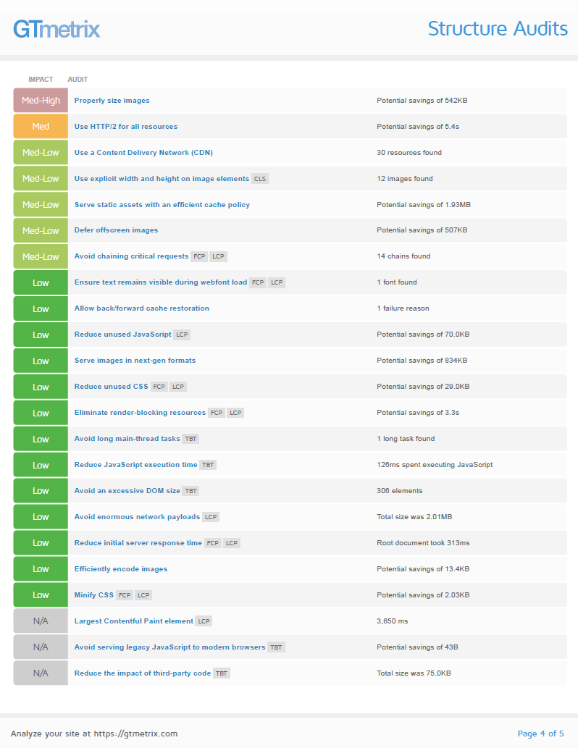

End of Report